**SCENARIO 1:  
 The bank wants to apply a discount to loan interest rates for customers above 60 years old.**

**CODE:**

BEGIN

FOR cust_rec IN (

SELECT c.CustomerID, c.DOB, l.LoanID, l.InterestRate

FROM Customers c

JOIN Loans l ON c.CustomerID = l.CustomerID

) LOOP

IF MONTHS_BETWEEN(SYSDATE, cust_rec.DOB) / 12 > 60 THEN

UPDATE Loans

SET InterestRate = InterestRate - 1

WHERE LoanID = cust_rec.LoanID;

DBMS_OUTPUT.PUT_LINE('1% discount applied for CustomerID: ' || cust_rec.CustomerID);

ELSE

DBMS_OUTPUT.PUT_LINE(' No discount for CustomerID: ' || cust_rec.CustomerID || ' (Age < 60)');

END IF;

END LOOP;

END;

**OUTPUT:**

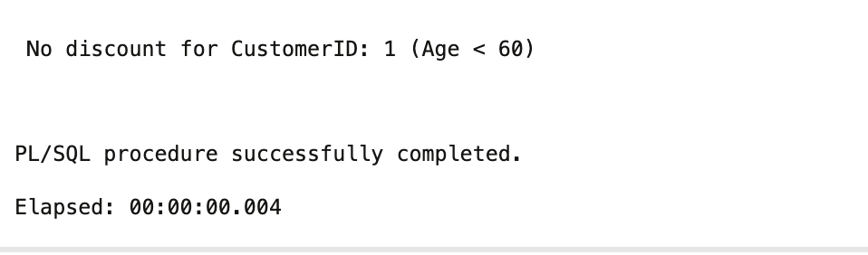

**SCENARIO 2:**

**A customer can be promoted to VIP status based on their balance.**

**CODE:**

BEGIN

FOR cust_rec IN (

SELECT CustomerID, Balance FROM Customers

) LOOP

IF cust_rec.Balance > 10000 THEN

UPDATE Customers

SET IsVIP = 'TRUE'

WHERE CustomerID = cust_rec.CustomerID;

DBMS_OUTPUT.PUT_LINE('CustomerID: ' || cust_rec.CustomerID || ' promoted to VIP status.');

ELSE

DBMS_OUTPUT.PUT_LINE('

CustomerID: ' || cust_rec.CustomerID || ' not eligible for VIP (Balance < 10000)');

END IF;

END LOOP;

END;

/

**OUTPUT:**

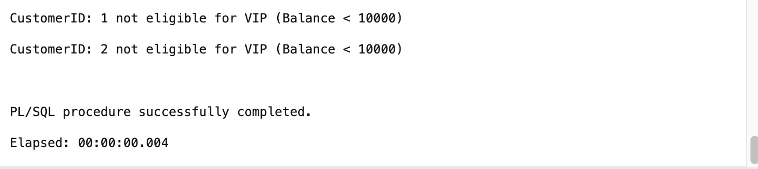

**SCENARIO 3**

**The bank wants to send reminders to customers whose loans are due within the next 30 days.**

**CODE:**

BEGIN

FOR loan_rec IN (

SELECT l.LoanID, l.CustomerID, c.Name, l.EndDate

FROM Loans l

JOIN Customers c ON l.CustomerID = c.CustomerID

WHERE l.EndDate <= SYSDATE + 30

) LOOP

DBMS_OUTPUT.PUT_LINE('Reminder: LoanID ' || loan_rec.LoanID ||

' for Customer ' || loan_rec.Name ||

' (CustomerID: ' || loan_rec.CustomerID ||

') is due on ' || TO_CHAR(loan_rec.EndDate, 'DD-MON-YYYY'));

END LOOP;

IF SQL%ROWCOUNT = 0 THEN

DBMS_OUTPUT.PUT_LINE('No loans due in the next 30 days.');

END IF;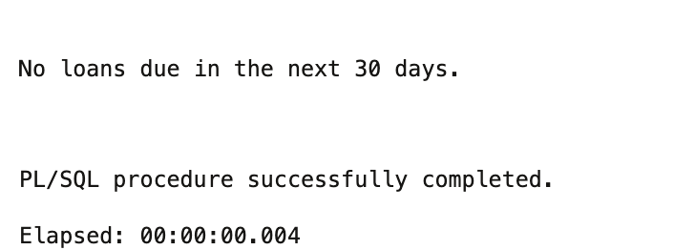

END;

/

**OUTPUT:**